**Department of computer science**

**ARTIFICIAL INTELLIGENCE LAB**

**Assignment 1: PYTHON BASICS:**

**(Python input output, variables, data types, strings ,List, dictionary, tuples, operators)**

***1 read it first***

Prior to start solving the problems in this assignments, please give full concentration on following points.

1. graded assignment – *yes*
2. working – This is individual assignment. If you are stuck in a problem contact your teacher, but, in mean time start doing next question (don’t waste time).
3. don’t cheat – You will be penalized with straight forward *zero* marks.
4. organization – This assignment is divided into two parts. In section 2, you are given

15 to 20 different formulae you have to make separate computer programs using python language for each of them. In section 3, you are given 20 different equations with answers, you have to provide the (*logical*) reasons for their answers.

1. submission – This assignment needs to be submitted in a *soft copy* through vle
2. where to submit – Please visit your VLE
3. how to submit – Run the code on software submit in zip form

in theory, theory and practice are the same. in practice, they’re not. yoggi berra.

**2 supercalifragilisticexpialidocious**

‘Supercalifragilisticexpialidocious’ is not a typo! It means extraordinarily good. There are twenty different supercalifragilisticexpialidocious formulae below, which are to be programmed using python as a programming language. The formulae are written in the mathematical notation, where · means multiplication. Other important things are:

1. Indent your code inside the main() function. It’s a good practice!
2. While programming, you have to use parenthesis ‘(’ and ‘)’ for enforcing the bodmas rule where it is required. If you don’t put parentheses safely, computer will execute the program with the precedence of operator with respect to python language. It may give you wrong answer and lead towards the failure of program.
3. In your program, for each question you have to write the resulting value in a proper format, with the unit ahead of the value.
4. Comment your code, where it is necessary.
5. Read the entire question. Don’t jump to the formula directly.

**The questions are below:**

1. Take distance *d* and time *t* from user with the appropriate data types, and then calculate the *speed* as per following formula:

speed 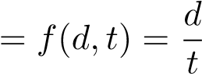

**Source Code:**

d=float(input("EnterDistance"))  
t=float(input("EnterTime"))  
s=(d/t)  
print("speed is:",s)

**Output:**

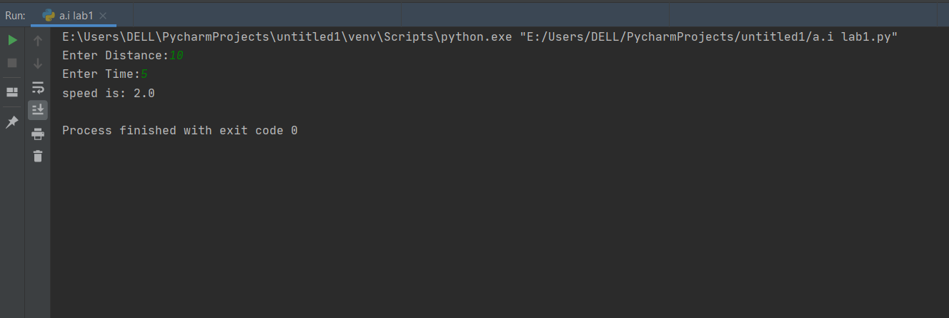

1. Take user defined inputs for initial velocity *v*, time *t* and acceleration *a*. Use appropriate data types for them accordingly. And then, calculate *final velocity* as per following formula. Remember there is multiplication between *a* and *t*.

final velocity = *f*(*v,t,a*) = *v* + *a* · *t*

***Source Code:***

v=int(input("Enter Velocity:"))

a=float(input("Enter Acceleration:"))

t=float(input("Enter Time:"))

vf=v + (a * t)

print("Final Velocity is:",vf)

**Output:**

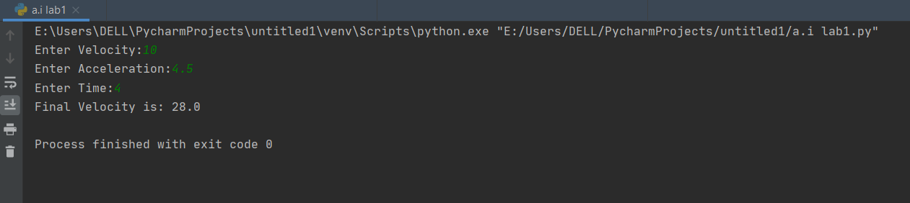

1. Take initial velocity *v*, final velocity *u* and time *t* from user with their appropriate format specifiers and data types accordingly. And then calculate *acceleration* as per following formula: acceleration 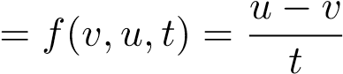

**Source Code:**

v=float(input("Enter Initial Velocity:"))

u=float(input("Final Velocity:"))

t=float(input("Enter Time:"))

a=(u-v)/t

print("acceleration is:",a)

**Output:**

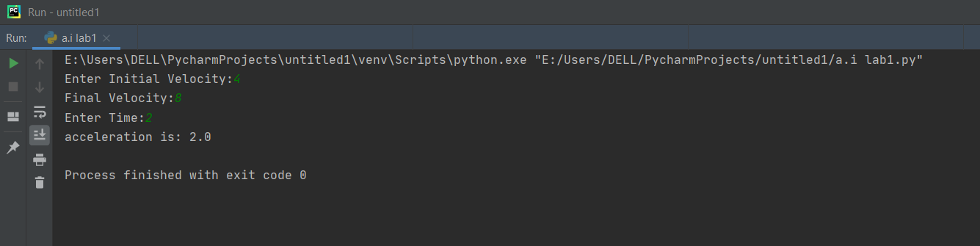

1. Make a program that asks user to enter temperature in ferinheight *f* and you have to convert that into *celsius* celcius 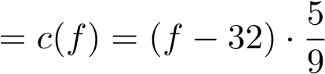

**Source Code:**

f=float(input("Enter Temperature In Farenhiet:"))

c=(f-32)*(5/9)

print("Temperature in Centigrade is:",c)

**Output:**

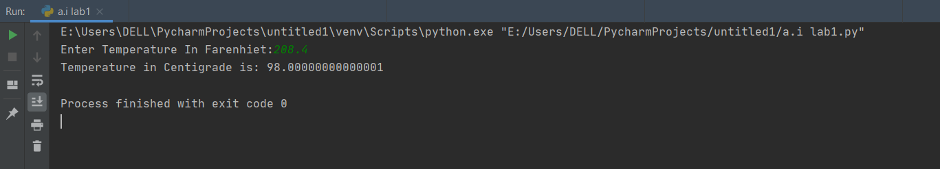

1. Take mass *m* and velocity *v* from user and calculate *kinetic energy* as per following formula:

kinetic energy 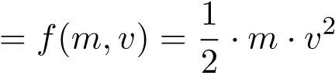

**Source Code:**

m=float(input("Enter Mass:"))

v=float(input("Enter Velocity:"))

ke=(1/2)*(m*v*v)

print("Kinetic Energy is:",ke)

**Output:**

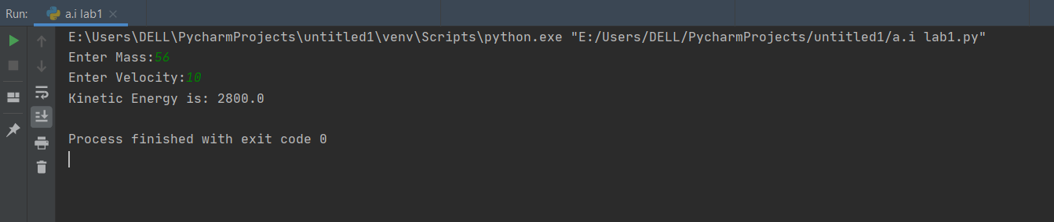

1. Take initial velocity *v*, time *t* and acceleration *a* from user. And save them in respective data types and calculate *distance* per following formula:

distance 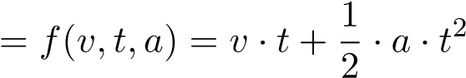

**Source Code:**

v=float(input("Enter Velocity:"))

t=float(input("Enter Time:"))

a=float(input("Enter acceleration:"))

d=(v*t)+(1/2)*(a*t*t)

print("Distance is:",d)

**Output:**

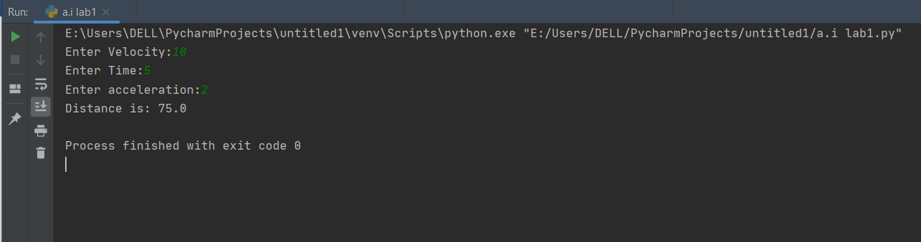

1. Take the value of the mass of the first body *m*1 and the mass of the second body *m*2 from the user. And calculate *reduced mass* per following formula:

reduced mass 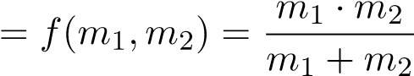

**Source Code:**

m1=float(input("Enter First Mass Value:"))

m2=float(input("Enter Second Mass Value:"))

rm = (m1*m2)/(m1+m2)

print("Reduce Mass is:",rm)

**Output:**

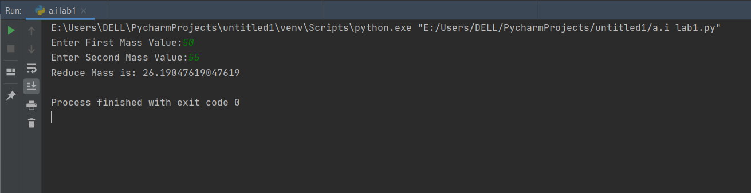

1. Make a program that calculates the *Newtonian gravity* as per following formula:

Newtonian gravity 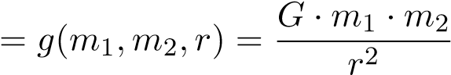

Where, *m*1 and *m*2 are the masses of two bodies, *r* is distance between the two bodies, and *G* is the universal gravitational constant which has a value of 6*.*67300 × 10−11, for which you are not supposed to take value as a user input; instead, you have to make a constant identifier in your program by using keyword const with appropriate data type and set the value accordingly.

**Source Code:**

m1=float(input("Enter First Mass Value:"))

m2=float(input("Enter Second Mass Value:"))

r=float(input("Enter Radius:"))

G = 6.673*(10**-11)

ng=(G*m1*m2)/(r*r)

print("Newton Gravity is:",ng)

**Output:**

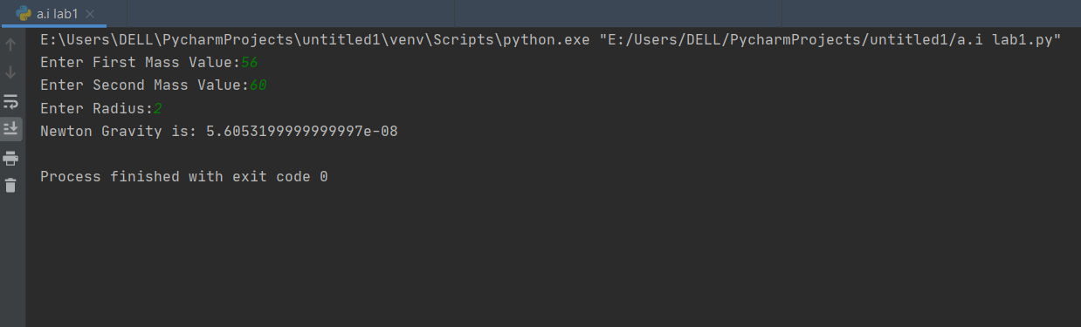

1. Write a program that will calculate %*composition* of an element as per following formula: %composition 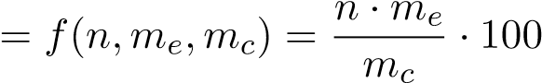

Where, *n* is the number of moles of the element in one mole of the compound, *me* is molar mass of element and *mc* is molar mass of compound.

**Source Code:**

n=float(input("Enter No of moles:"))

me=float(input("Enter molar mass:"))

pc=(n*me)/(me)*100

print("%composition:",pc)

**Output:**

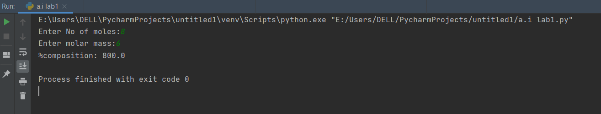

1. Write a program that will calculate energy of an electron in the nth state in a hydrogen atom. Below is the formula:

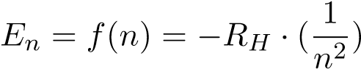

Where *RH* is the Rydberg constant with the value 2*.*18×10−18 J and *n* is the state number.

**Source Code:**

RH=2.18*pow(10,-18)

e1=RH/pow(1,2)

e2=RH /pow(2,2)

print("E1=",e1)

print("E2=",e2)

**Output:**

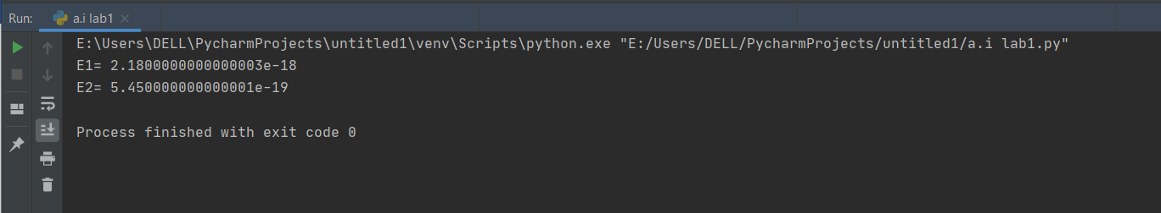

1. Write a program that will calculate *area of circle*, where value of *π* is 3.142 and it should be a constant value. area of circle = *f*(*r*) = *π* · *r*2

**Source Code:**

from math import pi

r = float(input ("Input the radius of the circle : "))

a=pi*pow(r,2)

print("Area Of Circle Is",a)

**Output:**

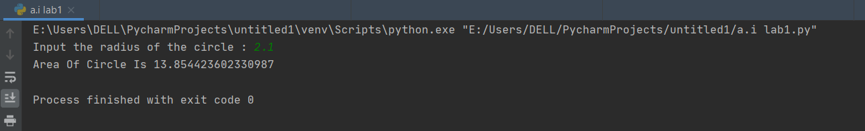

1. Write a program that will calculate *area of trapezoid*:

area of trapezoid 

**Source Code:**

h = float(input("Height of trapezoid: "))

b1 = float(input('Base one value: '))

b2 = float(input('Base two value: '))

a = ((b1 + b2) / 2) * h

print("Area Of Trapezoid is:", a)

**Output:**

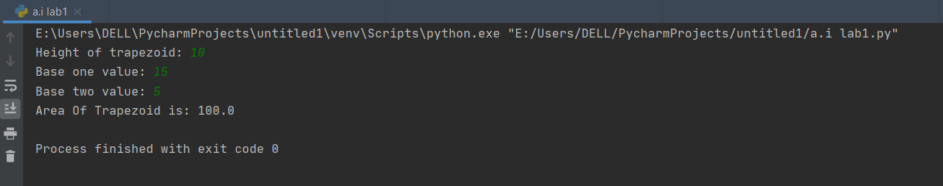

1. Write a program that will calculate *area of triangle*:

area of triangle 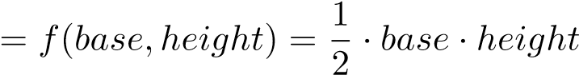

**Source Code**

b= float(input('Enter base side: '))

h = float(input('Enter second side: '))

# calculate the area

a =(1/2)*b*h

print("The area of the triangle is %0.2f"%a)

**Output:**

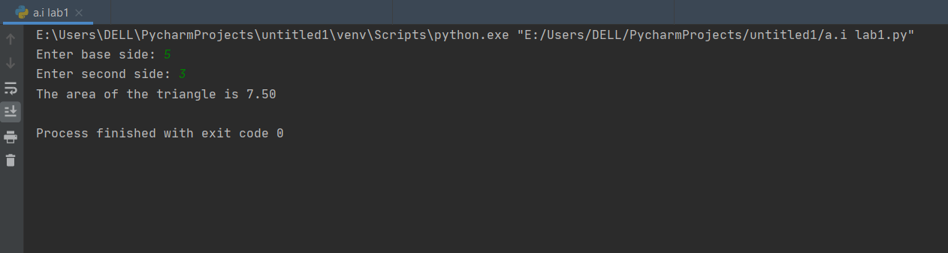

1. Write a program that will tell you how many *meters* are there in a mile. Where the value of *mile* is supposed to be input by user.

**Source Code:**

mi= float(input('Enter the value of miles: '))

m =mi/0.00062137

print("There are %0.2f meters in one mile"%m)

**Output:**

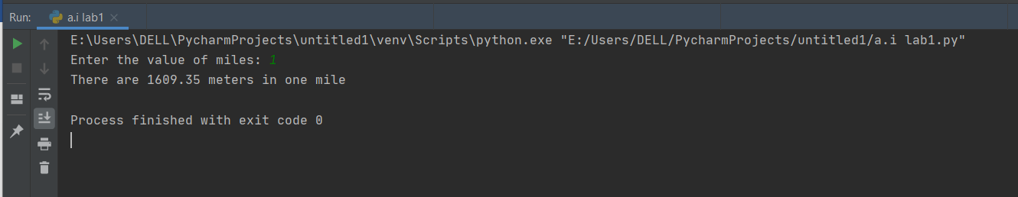

1. Make a program where it is asked from user to enter the *total amount*, you have to answer how much *Zakat* to be paid on that amount. Zakat is the 2.5% of the total amount.

**Source Code:**

t=float(input("Enter total amount: "))

z=(t/100)*2.5

print("Zakat to be paid on that amount is %0.2f"%z)

**Output:**

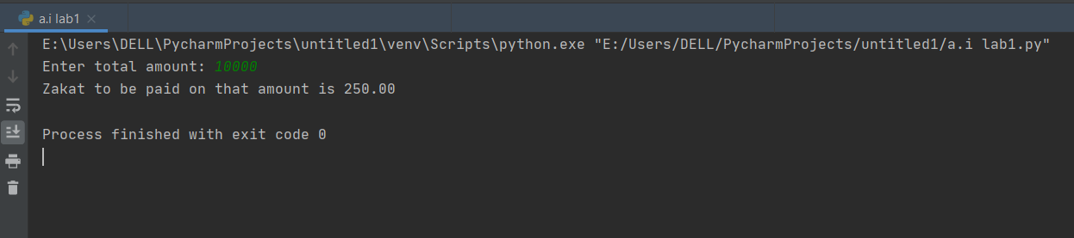

1. Make a program that will (first) ask the number of marks achieved in subjects and (then after clearing the screen) prints marks sheet. Total marks per subject is 100. The program should cater 5 subjects at least.

**Source Code:**

s1=int(input("Enter marks of the first subject: "))

s2=int(input("Enter marks of the second subject: "))

s3=int(input("Enter marks of the third subject: "))

s4=int(input("Enter marks of the fourth subject: "))

s5=int(input("Enter marks of the fifth subject: "))

avg=(s1+s2+s3+s4+s5)/5

if(avg>=90):

print("Grade: A")

elif avg>=80 and avg<90:

print("Grade: B")

elif avg>=70 and avg<80:

print("Grade: C")

elif avg>=60 and avg<70:

print("Grade: D")

else:

print("Grade: F")

**Output:**

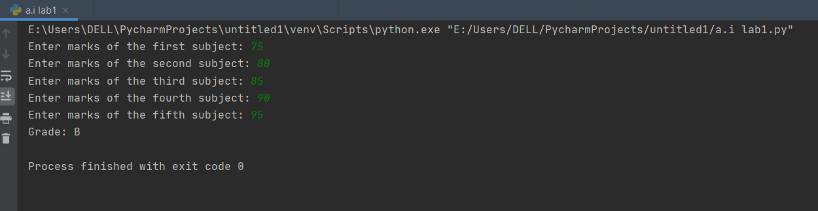

1. The following equation is meant to use all built-in function together, along with taking care of precedence of operator. Take value of *x* from user. And calculate *result* per following formula:

result 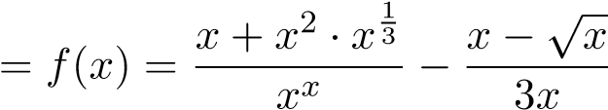

**Source Code:**

import math

x=int(input("enter value: "))

r=x+pow(x,2)*pow(x,(1/3))/(pow(x,x))+x-math.sqrt(x)/3*x

print("the result is %0.2f"%r)

**Output:**

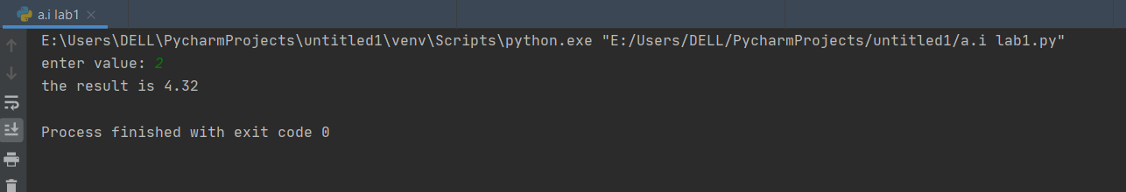

1. Write a program that evaluates the following equation. Take the data for all required input from user. Remember: you don’t have to compare the both sides of the equation, just show the results of equation on right and left sides. Obviously, it makes sense the input you are going to take for the right side will be good for the left side as well, thus, you are to take the input once and use it wherever it is required.



**Source Code:**

a=float(input("enter First value: "))

b=float(input("enter Secondvalue: "))

c=(a+b)*(pow(a,2)-a*b+pow(b,2))

print("the result is %0.2f"%c)

**Output:**

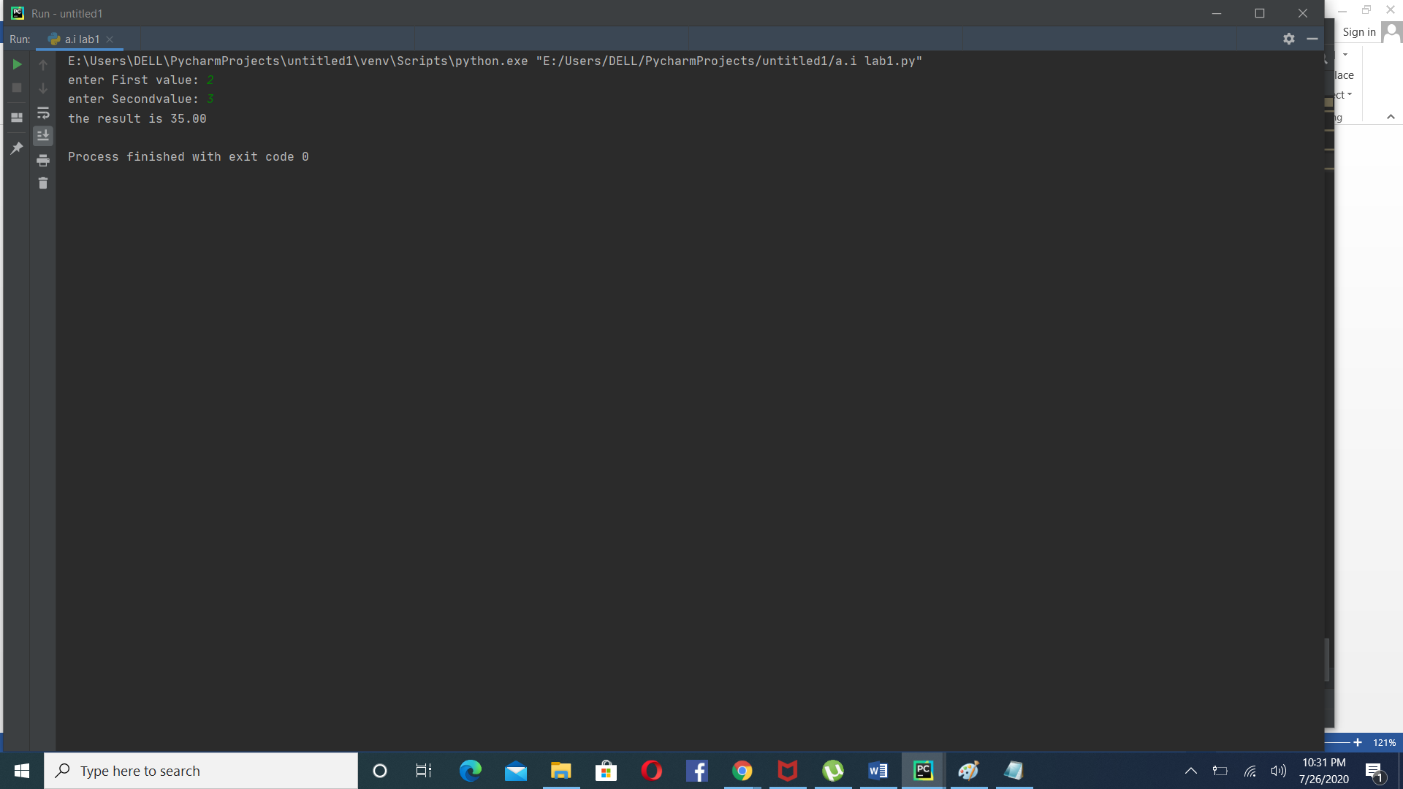

1. Write a program that will take all required data from user to solve the quadratic equation. Remember: from quadratic equation we yield two answers, i.e. positive and negative. Don’t confuse! repeat your code twice, once for the positive part, again for the negative. In end, modify your answer with the format accordingly.

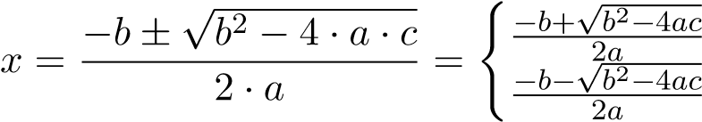

**Source Code:**

import cmath

a=float(input("Enter First Value:"))

b=float(input("Enter Second Value:"))

c=float(input("Enter Third Value:"))

# calculate the discriminant

d = pow(b,2) - (4*a*c)

# find two solutions

r1 = (-b-cmath.sqrt(d))/(2*a)

r2 = (-b+cmath.sqrt(d))/(2*a)

print('The roots are {0} and {1}'.format(r1,r2))

**Output:**

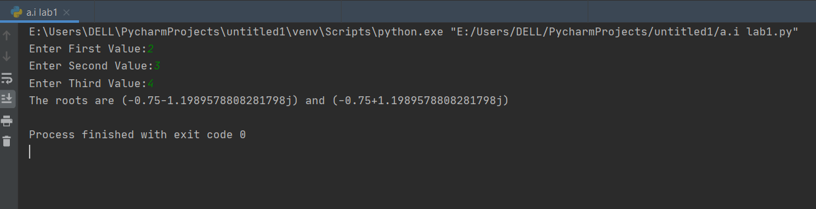

20.Design a menu driven program and perform the given operations using ‘TUPLES’

1. to convert a tuple to a string.
2. to add an item in a tuple.
3. to create a tuple with different data types
4. swap the two tuples

**Source code:**

a=input("press 1 : to convert tupple into string"

"\npress 2 : to add an item in a tuple"

"\npress 3: to create a tuple with different data types"

"\npress 4: to swap two tuples\n"

)

if a=='1':

tup = ('e', 'x', 'e', 'r', 'c', 'i', 's', 'e', 's')

str = ''.join(tup)

print(str)

elif a=='2':

tuplex = (4, 6, 2, 8, 3, 1)

print(tuplex)

# tuples are immutable, so you can not add new elements

# using merge of tuples with the + operator you can add an element and it will create a new tuple

tuplex = tuplex + (9,)

print(tuplex)

# adding items in a specific index

tuplex = tuplex[:5] + (15, 20, 25) + tuplex[:5]

print(tuplex)

# converting the tuple to list

listx = list(tuplex)

# use different ways to add items in list

listx.append(30)

tuplex = tuple(listx)

print(tuplex)

elif a=='3':

tuplex = ("tuple", False, 3.2, 1)

print(tuplex)

elif a=='4':

x=(1,2,3,4,5)

y=(6,7,8,9,10)

# create a temporary variable and swap the values

temp = x

x = y

y = temp

print('The value of x after swapping: {}'.format(x))

print('The value of y after swapping: {}'.format(y))

**Output:**

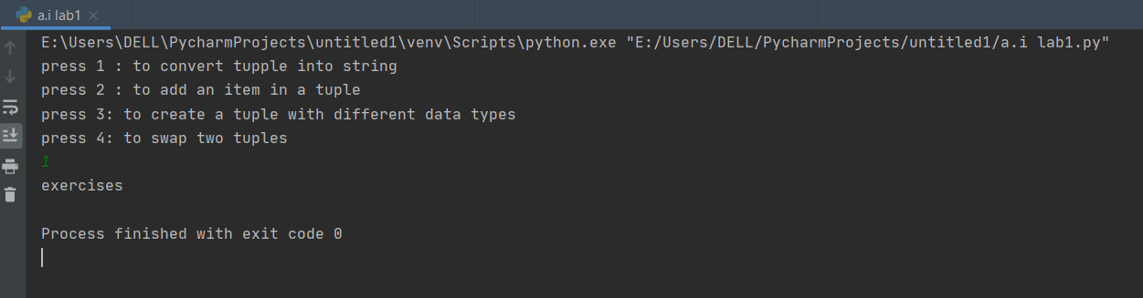

1. Arrange String characters such that lowercase letters should come first

Given input String of combination of the lower and upper case arrange characters insuch a way that all lowercase letters should come first.

**Expected Output:**

input_String = PyNaTive

arranging characters giving precedence to lowercase letters

aeiNPTvy

arranging characters giving precedence to lowercase letters:

yaivePNT

**Source Code:**

str1 = "Hello Dear"

words = str1.split()

lower = []

upper = []

for char in str1:

if char.islower():

lower.append(char)

else:

upper.append(char)

sorted_string = ''.join(lower + upper)

print("\n arranging characters giving precedence to lowercase letters:")

print(sorted_string)

**Output:**

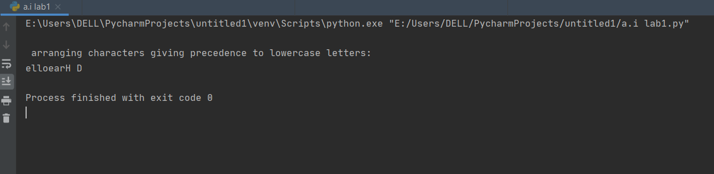

22. Access the value of key ‘history’(concept of dictionary)

sampleDict = {

"class":{

"student":{

"name":"hira farman",

"marks":{

"physics":70,

"history":100

}

}}}}

}

**Source Code:**

sampleDict = {

"class":{

"student":{

"name":"Mike",

"marks":{

"physics":70,

"history":100

}

}

}

}

print(sampleDict['class']['student']['marks']['history'])

**Output:** 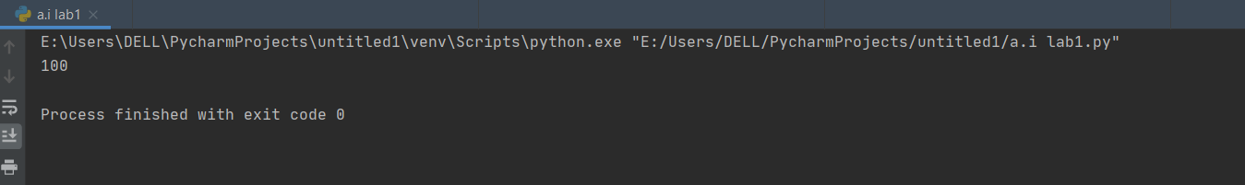

23. Delete set of keys from Python Dictionary

Given:

sampleDict = {

"name": "Kelly",

"age":25,

"salary": 8000,

"city": "New york"

}

keysToRemove = ["name", "salary"]

**Expected output:**

**{'city': 'New york', 'age': 25}**

**Source Code:**

sampleDict = {

"name": "Kelly",

"age":25,

"salary": 8000,

"city": "New york"

}

keysToRemove = ["name", "salary"]

sampleDict = {k: sampleDict[k] for k in sampleDict.keys() - keysToRemove}

print(sampleDict)

**Output:**

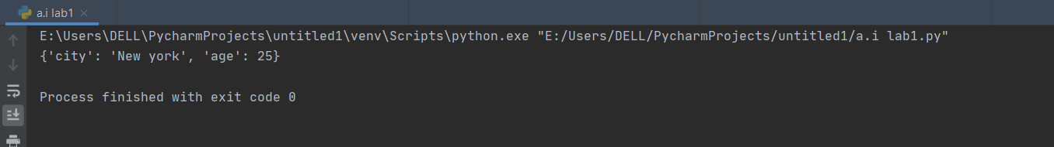

24.what will be the output of the give program.

a = 90

b = 69

print("Bitwise AND Operator On 90 and 69 is = ", a & b)

print("Bitwise OR Operator On 90 and 69 is = ", a | b)

print("Bitwise EXCLUSIVE OR Operator On 90 and 69 is = ", a ^ b)

print("Bitwise NOT Operator On 90 is = ", ~a)

print("Bitwise LEFT SHIFT Operator On 90 is = ", a << 1) print("Bitwise RIGHT SHIFT Operator On 69 is = ", b >> 1)

**Output:**

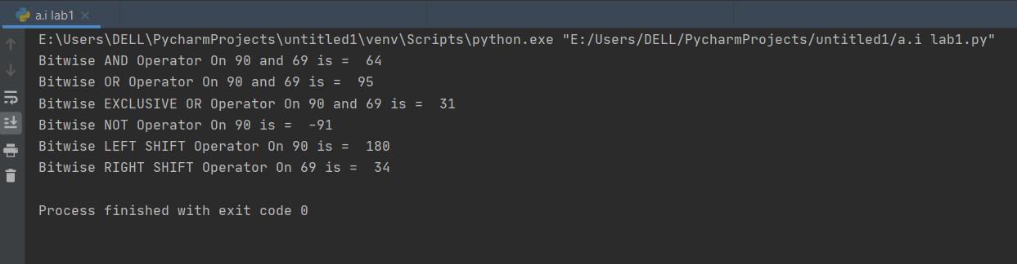

25.Write a Python program to find missing and additional values in two lists.   
 **Sampledata:Missing values in second list: b,a,c**

**Additional values in second list: g,h**

**Source Code:**

l1 = ['a','b','c','d','e','f']

l2 = ['d','e','f','g','h']

print("Missing values in second list:", (set(l1).difference(l2)))

print("Additional values in second list:", (set(l2).difference(l1)))

**Output:**

